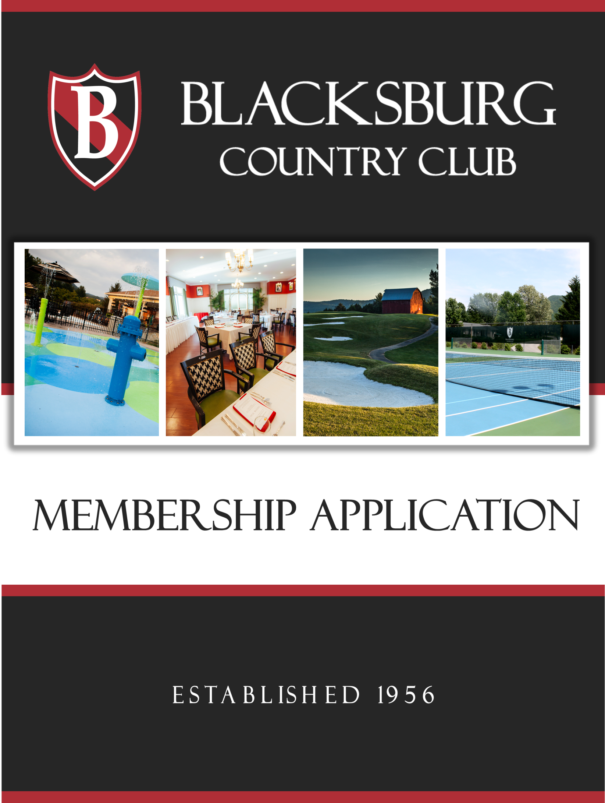
MEMBER BENEFITS AND DUES
BY MEMBERSHIP CLASSIFICATION:
Each new membership is subject to an initiation fee which includes $250 in equity stock (5 shares) in the Club. Annual dues may be paid monthly (5% surcharge), quarterly, or annually. All memberships, with the exception of Non-Resident, are charged a $60 monthly capital fee for debt retirement and capital improvements.

FULL ME MBE R SHIP
Entitles member and spouse or partner and dependent children under age 25 to full use of all Club facilities: golf, tennis, pool, fitness, and clubhouse.
Annual Dues:
For up to date fee please contact DeAnne Webb- Membership Director at (540) 552-9165 or membership@blaccksburgcc.com.

SIN GL E ME MBE R SHIP
Entitles a member who is not married and his or her dependent children under age 25 the same privileges as Full Membership.
Annual Dues:
For up to date fee please contact DeAnne Webb- Membership Director at (540) 552-9165 or membership@blaccksburgcc.com.

JUNIO R MEMBER SHIP
(limited to persons between ages 21 – 31)
Member Benefits: Same as Full Membership
Annual Dues:
For up to date fee please contact DeAnne Webb- Membership Director at (540) 552-9165 or membership@blaccksburgcc.com.

ADAVCED JUNIO R MEMBER SHIP
(limited to persons between ages 32 – 36). Dues “step” from junior to full over a five year period.
Member Benefits: Same as Full Membership.
Annual Dues
For up to date fee please contact DeAnne Webb- Membership Director at (540) 552-9165 or membership@blaccksburgcc.com.

SENIOR MEMBERSHIP
(limited to persons age 65 and older).
Membership Benefits: Same as Full Membership but may only play golf Monday through Friday.
Annual Dues:
For up to date fee please contact DeAnne Webb- Membership Director at (540) 552-9165 or membership@blaccksburgcc.com.

RECREATIONAL M EM B ERS H I P
Member Benefits: Entitles member and spouse or partner and dependent children under age 25 to full use of the following Club facilities: tennis, pool, fitness, and clubhouse. Includes one round of golf per month at a discounted green fee.
Annual Dues:
For up to date fee please contact DeAnne Webb- Membership Director at (540) 552-9165 or membership@blaccksburgcc.com.

SOCIAL M EM B ERS H I P
Member Benefits: Entitles member and spouse or partner and dependent children under age 25 to full use of the Club’s dining facility and social events.
Annual Dues:
For up to date fee please contact DeAnne Webb- Membership Director
at (540) 552-9165 or membership@blaccksburgcc.com.

ASSOCIATE MEMBERSHIP
(limited to persons residing 36-75 air miles from BCC).
Member Benefits: Same privileges as Full Membership.
Annual Dues:
For up to date fee please contact DeAnne Webb- Membership Director
at (540) 552-9165 or membership@blaccksburgcc.com.

NON-RESIDENT MEMBERSHIP
(limited to persons residing more than 75 air miles from BCC). Member Benefits: Same privileges as Full Membership.
Annual Dues:
For up to date fee please contact DeAnne Webb- Membership Director
at (540) 552-9165 or membership@blaccksburgcc.com.

CORPORATE MEMBERSHIP
Between three and eight employees may be listed under one corporate membership umbrella and pay just one initiation fee (dues apply to each membership). Designees may be changed without payment of an additional initiation fee.
Annual Dues:
For up to date fee please contact DeAnne Webb- Membership Director
at (540) 552-9165 or membership@blaccksburgcc.com.

*Effective January 15, 2020

BLACKSBURG COUNTRY CLUB TERMS AND CONDITIONS TO MEMBERSHIP APPLICATION

By signing the Blacksburg Country Club Membership Application (the “Application”), the Applicant and his/her spouse or partner (if applicable) listed therein, agree to the following terms and conditions if their application for membership is accepted Blacksburg Country Club, Inc. (the “Club”):

- The Applicant hereby authorizes BCC, Inc. to check credit and employment history and to obtain other information the Club deems necessary to extend credit to the Applicant and his/her spouse or partner (if applicable).

- The Applicant will be liable for the payment of dues as established by the Club for the applicable membership classification for the entire member ship year (April 1 to March 31) or until the membership is cancelled as set forth herein below. The Applicant hereby agrees to be liable for any fees and/or charges incurred by the Applicant, the Applicant’s spouse or partner, their children, and their guests, including food and beverages, purchases of merchandise, lessons or camps, guest fees for golf, tennis and the pool and damage to Club property caused by the actions of the Applicant, the Applicant’s spouse or partner, and/or their children, and their guests.

- The Applicant may only cancel his/her membership by giving written notice of such intent no later than March 1 of any year to be effective as of March 31. Exceptions to the annual dues obligation will be granted should the Applicant move more than 75 air miles from the Club or meet Leave of Absence guidelines as listed in the Club’s bylaws.

- The Applicant agrees to comply with the provisions of the Application, these Terms and Conditions thereto, Club bylaws, the member handbook, and any other rules or regulations promulgated by the Club, including as amended from time to time.

- All fees and charges shall be billed to Applicant monthly. All amounts due to the Club shall be payable upon receipt. Applicant agrees that the Club may charge an interest rate of 1.5% per month on any past due amounts owed the Club. If any payment is not received by the end of the month following the statement date, the Applicant hereby authorizes the Club to assess a finance charge on the past due balance. The Applicant shall pay any and all costs and expenses incurred by the Club in collecting any unpaid charges, including court costs or the Club’s reasonable attorney’s fees.

Please keep pages 1-2 for future reference.
Pages 3-4 should be given to the Club.

BLACKSBURG COUNTRY CLUB MEMBERSHIP APPLICATION
O FF I C E U S E O N LY: MEMBER #

TYPE OF MEMBERSHIP APPLYING FOR (see Terms & Conditions for detailed descriptions)

❑ Full  Single  Junior  Adv. Junior  Senior  Associate  Non Resident  Recreational  Social  Corporate

PRIMARY APPLICANT’S INFORMATION:

CONTACT INFORMATION
First Name | Last Name Title (Mr./Mrs./Ms./Dr.)
Home Address | City | State | Zip Code
Home Phone | Cell Phone | E-mail
Social Security Number  (for credit report purposes only) | Date of Birth  (mm/dd/yyyy) | Wedding Anniv.  (if applic. mm/dd/yyyy)

ADDRESS FOR NEWSLETTER CORRESPONDENCE AND BILLING (if different from above)
Address | City | State | Zip Code

E M P LOYM E NT I N F O R MATI O N

Occupation (or retired if applicable)
Employer | Title |  | Years
Business Address | City | State | Zip Code
Business Phone

SPOUSE OR PARTNER INFORMATION:

❑ Spouse  Partner (with durable power of attorney)

CON TACT I N FOR M AT ION
First Name | Last Name Title (Mr./Mrs./Ms./Dr.)
Phone | Cell Phone
Date of Birth  (mm/dd/yyyy) | E-mail

E M P LOYM E NT I N F O R MATI O N

Occupation (or retired if applicable)

Employer | Title |  | Years
Business Address | City | State | Zip Code
Business Phone

FAMILY INFORMATION

NAM E S & B I RTH DAYS O F C H I LD R E N U N D E R 25
First | Last | Birth  (mm/dd/yy) | Gender | Cell  (if any)
First | Last | Birth  (mm/dd/yy) | Gender | Cell  (if any)
First | Last | Birth  (mm/dd/yy) | Gender | Cell  (if any)
First | Last | Birth  (mm/dd/yy) | Gender | Cell  (if any)
First | Last | Birth  (mm/dd/yy) | Gender | Cell  (if any)
First | Last | Birth  (mm/dd/yy) | Gender | Cell  (if any)

REFERENCE INFORMATION

PLEASE LIST TWO PERSONAL OR BUSINESS REFERENCES

Name Phone

Name Phone

BILLING PREFERENCES

I prefer to pay – Dues:  Annually  Quarterly  Monthly
Capital:  Annually  Quarterly  Monthly

The Club utilizes electronic billing statements. Please email:  Primary applicant  Spouse/Partner  Both

Would you like to participate in electronic debit of a bank account?  Yes  No If yes, complete attached form.

INTEREST AREAS (please check as appropriate)

❑ Golf  Tennis  Aquatics  Social Events  Couple’s Events  Networking  Fitness

❑ Swim Team  Youth Camps  Sports Instruction  Birthday Parties  Family Activities

By signing below, I certify that the foregoing information and any supplemental information provided to Blacksburg Country Club (the “Club”) is true and correct. I acknowledge that I have received, have read, fully understand and agree to the Blacksburg Country Club Terms & Conditions to the Membership Application, including dues year dates and cancellation of membership. I understand that my acceptance as a member of Blacksburg CC is subject to approval by the Club and that such acceptance may be withheld by the Club at its sole discretion. I understand that my membership right may, from time to time, be modified by duly adopted changes to the Club’s by-laws, rules and/or regulations and that my membership is expressly subject to such by-laws, rules and/or regulations and any changes thereto.

Applicant’s Printed Name Applicant’s Signature

Spouse’s / Partner’s Printed Name Spouse’s / Partner’s Signature

Date of Application

